**Bug code: 1**

**Bug name: name as numbers**

**Bug Description:** add invalid lecturer , Writing numbers as lecturer name

**The bug writer:Yousif Hibi**

**Date of writing of the bug : 25.12.2024**

**Severity of the bug: high**

**Reproduce bug: -**

1. open the URL on add lecturer site
2. Moving the mouse to the Lecturer name field and click on it add a name
3. Moving the mouse to the Lecturer email field and click on it add a email
4. Moving the mouse to the Academic Degree field and click on it add a text
5. Moving the mouse to the Assign to Course field and choose a course
6. Click on Add Lecturer button

**Screen Shoot :-**

**Bug code: 2**

**Bug name:** invalid lecturer email

**Bug Description:** add invalid lecturer email , invalid lecturer email format

**The bug writer:Yousif Hibi**

**Date of writing of the bug : 25.12.2024**

**Severity of the bug: high**

**Reproduce bug: -**

1. open the URL on add lecturer site
2. Moving the mouse to the Lecturer name field and click on it add a name
3. Moving the mouse to the Lecturer email field and click on it add a text
4. Moving the mouse to the Academic Degree field and click on it add a text
5. Moving the mouse to the Assign to Course field and choose a course
6. Click on Add Lecturer button

**Screen Shoot :-**

**Bug code:3**

**Bug name:** invalid Academic Degree

**Bug Description:** add invalid Academic Degree, numbers instead of text

**The bug writer:Yousif Hibi**

**Date of writing of the bug : 25.12.2024**

**Severity of the bug:high**

**Reproduce bug: -**

1. open the URL on add lecturer site
2. Moving the mouse to the Lecturer name field and click on it add a name
3. Moving the mouse to the Lecturer email field and click on it add a email
4. Moving the mouse to the Academic Degree field and click on it add a numbers
5. Moving the mouse to the Assign to Course field and choose a course
6. Click on Add Lecturer button

**Screen Shoot :-**

**Bug code:4**

**Bug name:** sending an email

**Bug Description:** Resending invoice to student with paid status

**The bug writer:Yousif Hibi**

**Date of writing of the bug : 25.12.2024**

**Severity of the bug:low**

**Reproduce bug: -**

1. open the URL on Student Payment Status & Invoice Resend
2. Moving the mouse to the pop-up and click on the ok button

**Screen Shoot :-**

**Bug code:5**

**Bug name:** duplicate data

**Bug Description:** assigning duplicate same lecturer to the course

**The bug writer:Yousif Hibi**

**Date of writing of the bug : 25.12.2024**

**Severity of the bug:high**

**Reproduce bug: -**

1. open the URL on Course Allocation
2. Moving the mouse to Select Lecturer select list and select a lecturer
3. Moving the mouse to Select Course select list and select a Course
4. Moving the mouse to assign Course button and click it

**Screen Shoot :-**

**Bug code:6**

**Bug name:** coursename field as number

**Bug Description:** Create a New Course, name field as number

**The bug writer:Yousif Hibi**

**Date of writing of the bug : 25.12.2024**

**Severity of the bug: high**

**Reproduce bug: -**

1. open the URL on Create a New Course
2. Moving the mouse to Select Course Name field and enter a name
3. Moving the mouse to Select Course Description field and enter a name
4. Moving the mouse to Select Prerequisites field and enter a name
5. Moving the mouse to Select from Select Lecturer list and Select a Lecturer
6. Moving the mouse to Select from Course Date and Select a Date
7. Moving the mouse to Select from Course time and Select a Time
8. Moving the mouse to Select the create Course button and click it
9. Moving the mouse to Select the ok button

**Screen Shoot :-**

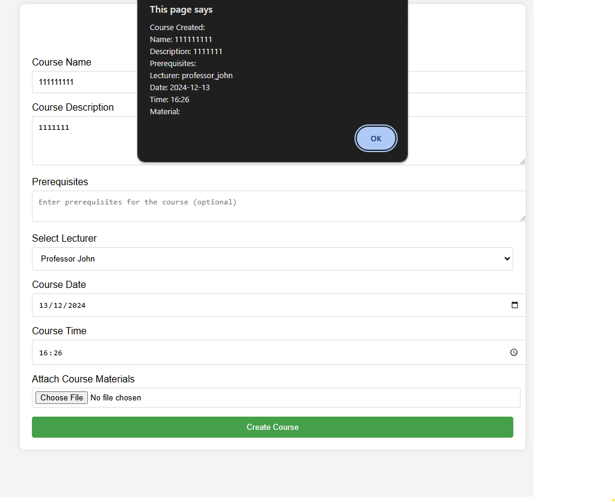

**Bug code:7**

**Bug name:** coursename field as space

**Bug Description:** Create a New Course, name field as space

**The bug writer:Yousif Hibi**

**Date of writing of the bug : 25.12.2024**

**Severity of the bug: high**

**Reproduce bug: -**

1. open the URL on Create a New Course
2. Moving the mouse to Select Course Name field and enter a space
3. Moving the mouse to Select Course Description field and enter a name
4. Moving the mouse to Select Prerequisites field and enter a name
5. Moving the mouse to Select from Select Lecturer list and Select a Lecturer
6. Moving the mouse to Select from Course Date and Select a Date
7. Moving the mouse to Select from Course time and Select a Time
8. Moving the mouse to Select the create Course button and click it
9. Moving the mouse to Select the ok button

**Screen Shoot :-**

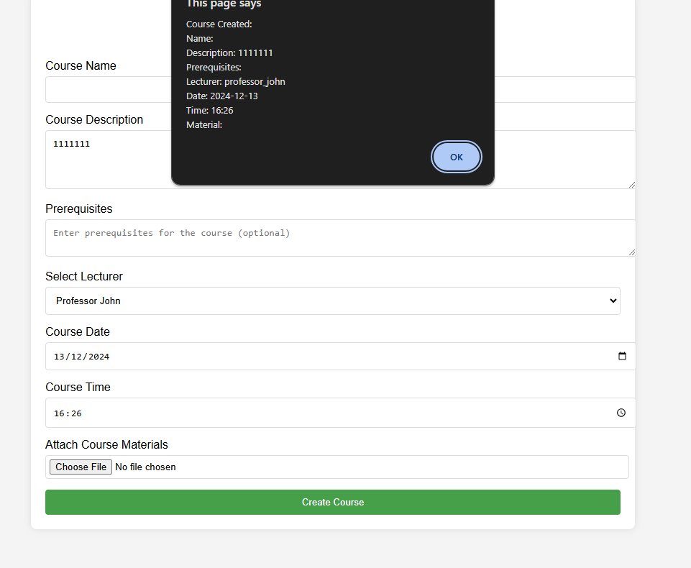

**Bug code:8**

**Bug name:** Course Description field as number

**Bug Description:** Create a New Course, Course Description field as number

**The bug writer:Yousif Hibi**

**Date of writing of the bug : 25.12.2024**

**Severity of the bug: high**

**Reproduce bug: -**

1. open the URL on Create a New Course
2. Moving the mouse to Select Course Name field and enter a name
3. Moving the mouse to Select Course Description field and enter a number
4. Moving the mouse to Select Prerequisites field and enter a name
5. Moving the mouse to Select from Select Lecturer list and Select a Lecturer
6. Moving the mouse to Select from Course Date and Select a Date
7. Moving the mouse to Select from Course time and Select a Time
8. Moving the mouse to Select the create Course button and click it
9. Moving the mouse to Select the ok button

**Screen Shoot :-**



**Bug code:9**

**Bug name:** empty field

**Bug Description:** Create a New Invoice Creation,empty Buyer's Name

**The bug writer:Yousif Hibi**

**Date of writing of the bug : 25.12.2024**

**Severity of the bug: high**

**Reproduce bug: -**

1. open the URL on **Invoice Creation**
2. leaving empty the Buyer's Name field
3. Moving the mouse to Select Buyer's Email field and enter a email
4. Moving the mouse to Select Buyer's Address field and enter a name
5. Moving the mouse to Select Amount field and enter a number
6. Moving the mouse to Select from Payment Type and Select a Payment Type
7. Moving the mouse to Select Discount Code field and entre a the code
8. Moving the mouse to Select the Discount Amount enter a number
9. Moving the mouse to Select the submit button
10. Moving the mouse to Select the ok button

**Screen Shoot :-**

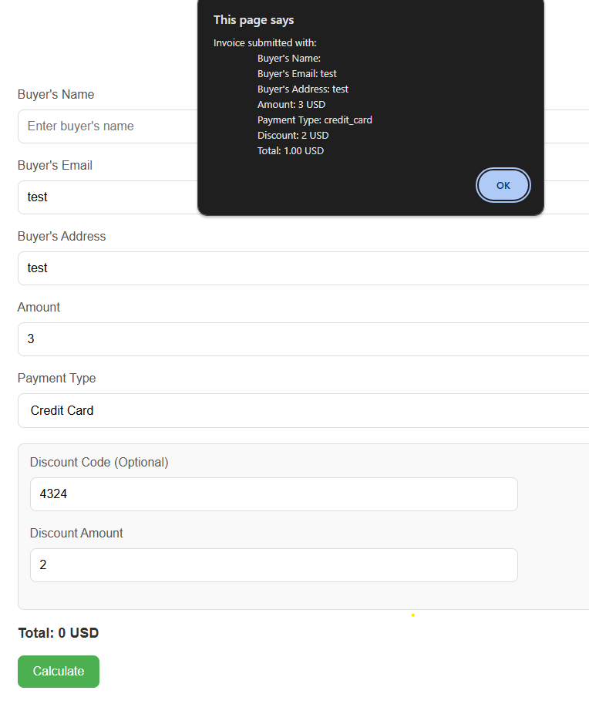

**Bug code:10**

**Bug name:** empty field

**Bug Description:** Create a New Invoice Creation,empty Buyer's Email

**The bug writer:Yousif Hibi**

**Date of writing of the bug : 25.12.2024**

**Severity of the bug: high**

**Reproduce bug: -**

1. open the URL on **Invoice Creation**
2. Moving the mouse to Select Buyer's name field and enter a name
3. Leaving the Buyer's Email empty
4. Moving the mouse to Select Buyer's Address field and enter a name
5. Moving the mouse to Select Amount field and enter a number
6. Moving the mouse to Select from Payment Type and Select a Payment Type
7. Moving the mouse to Select Discount Code field and entre a the code
8. Moving the mouse to Select the Discount Amount enter a number
9. Moving the mouse to Select the submit button
10. Moving the mouse to Select the ok button

**Screen Shoot :-**

**Bug code:11**

**Bug name:** wrong Buyer's Email format

**Bug Description:** Create a New Invoice Creation, wrong Buyer's Email format

**The bug writer:Yousif Hibi**

**Date of writing of the bug : 25.12.2024**

**Severity of the bug: high**

**Reproduce bug: -**

1. open the URL on **Invoice Creation**
2. Moving the mouse to Select Buyer's name field and enter a name
3. Moving the mouse to Select Buyer's Email field and enter a email
4. Moving the mouse to Select Buyer's Address field and enter a name
5. Moving the mouse to Select Amount field and enter a number
6. Moving the mouse to Select from Payment Type and Select a Payment Type
7. Moving the mouse to Select Discount Code field and entre a the code
8. Moving the mouse to Select the Discount Amount enter a number
9. Moving the mouse to Select the submit button
10. Moving the mouse to Select the ok button

**Screen Shoot :-**



**Bug code:12**

**Bug name:** empty field

**Bug Description:** testing discount and calculate , empty Discount code

**The bug writer:Yousif Hibi**

**Date of writing of the bug : 25.12.2024**

**Severity of the bug: extreme**

**Reproduce bug: -**

1. open the URL on **Invoice Creation**
2. **all fields are full other the Amount, discount code , Discount Amount.**
3. Moving the mouse to Select the Amount enter a number
4. Leaving the code empty
5. Moving the mouse to Select the Discount Amount enter a number
6. Moving the mouse to Select the calculate button

**Screen Shoot :-**

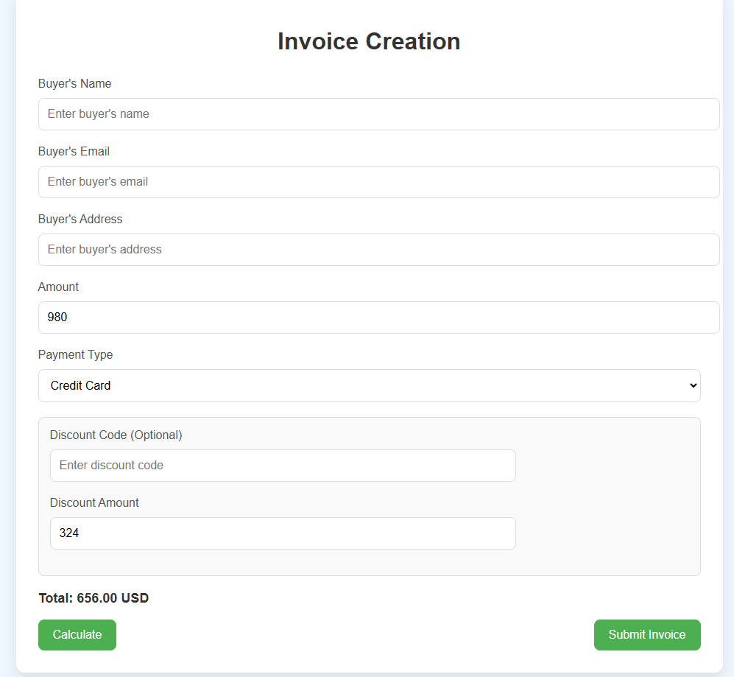

**Bug code:13**

**Bug name:** empty field

**Bug Description:** testing Provide Ongoing Feedback,empty feedback

**The bug writer:Yousif Hibi**

**Date of writing of the bug : 25.12.2024**

**Severity of the bug: low**

**Reproduce bug: -**

1. open the URL on Provide Ongoing Feedback
2. Leave the feedback empty
3. Moving the mouse to Submit button and click it
4. Moving the mouse to ok button and click it

**Screen Shoot :**

**Bug code:14**

**Bug name:** email wrong format

**Bug Description:** testing editing a Existing Lecturer,testing email wrong format

**The bug writer:Yousif Hibi**

**Date of writing of the bug : 25.12.2024**

**Severity of the bug: high**

**Reproduce bug: -**

1. open the URL on Manage Existing Lecturers
2. Moving the mouse to edit button and click it
3. Moving the mouse to Lecturer Email and change the text
4. Moving the mouse to update Lecturer button and click it

**Screen Shoot :**

**Bug code:15**

**Bug name:** empty filed

**Bug Description:** testing editing a Existing Lecturer,empty email or name

**The bug writer:Yousif Hibi**

**Date of writing of the bug : 25.12.2024**

**Severity of the bug: low**

**Reproduce bug: -**

1. open the URL on Manage Existing Lecturers
2. Moving the mouse to edit button and click it
3. Moving the mouse to Lecturer Email and leave empty
4. Moving the mouse to update Lecturer button and click it
5. Nothing happens

**Bug code:16**

**Bug name:** only numbers in a text filed

**Bug Description:** testing editing a Existing Lecturer,numbers in email or name no words

**The bug writer:Yousif Hibi**

**Date of writing of the bug : 25.12.2024**

**Severity of the bug:high**

**Reproduce bug: -**

1. open the URL on Manage Existing Lecturers
2. Moving the mouse to edit button and click it
3. Moving the mouse to Lecturer Email or name and add numbers
4. Moving the mouse to update Lecturer button and click it

**Screenshot :**

**Bug code:17**

**Bug name:** delete button

**Bug Description:** testing the delete button

**The bug writer:Yousif Hibi**

**Date of writing of the bug : 25.12.2024**

**Severity of the bug:high**

**Reproduce bug: -**

1. open the URL on Manage Existing Courses
2. Moving the mouse to delete button and click it
3. Moving the mouse to ok button and click it
4. Moving the mouse to ok button and click it
5. Nothing happens

**Bug code:18**

**Bug name:** invalid email

**Bug Description:** testing new Student Registration ,invalid email

**The bug writer:Yousif Hibi**

**Date of writing of the bug : 25.12.2024**

**Severity of the bug:high**

**Reproduce bug: -**

1. open the URL on Student Registration
2. Moving the mouse to Full Name and write a the name
3. Moving the mouse to Date of Birth filed and add a date
4. Moving the mouse to Email address and write a text
5. Moving the mouse to Phone Number and write a the number
6. Moving the mouse to Address and write a the Address
7. Moving the mouse to ID Number and write a the number
8. Moving the mouse to Course/Program and select a course
9. Moving the mouse to Upload ID Photo filed and click the choose a file and choose a file
10. Moving the mouse to submit button and click it

**Bug code:19**

**Bug name:** text instead of number

**Bug Description:** testing new Student Registration ,text in Phone Number or ID Number

**The bug writer:Yousif Hibi**

**Date of writing of the bug : 25.12.2024**

**Severity of the bug:high**

**Reproduce bug: -**

1. open the URL on Student Registration
2. Moving the mouse to Full Name and write a the name
3. Moving the mouse to Date of Birth filed and add a date
4. Moving the mouse to Email address and write a text
5. Moving the mouse to Phone Number and write a text
6. Moving the mouse to Address and write a the Address
7. Moving the mouse to ID Number and write a the number
8. Moving the mouse to Course/Program and select a course
9. Moving the mouse to Upload ID Photo filed and click the choose a file and choose a file
10. Moving the mouse to submit button and click it

**Bug code:20**

**Bug name:** invalided email

**Bug Description:** testing Send Invoice via Email , invalided email

**The bug writer:Yousif Hibi**

**Date of writing of the bug : 25.12.2024**

**Severity of the bug:high**

**Reproduce bug: -**

1. open the URL on Send Invoice via Email
2. Moving the mouse to Buyer's Email and type a text
3. Moving the mouse to Email Subject and type a text
4. Moving the mouse to Email Message and type a text
5. Moving the mouse to send email button and click it
6. Moving the mouse to ok button and click it

**Screenshot:**

**Bug code:21**

**Bug name:** empty field

**Bug Description:** testing Student Grade Entry, empty grade

**The bug writer:Yousif Hibi**

**Date of writing of the bug : 25.12.2024**

**Severity of the bug:high**

**Reproduce bug: -**

1. open the URL on Student Grade Entry
2. Moving the mouse to grade and leave it empty
3. Moving the mouse to Comments and type a text
4. Moving the mouse to Submit button and click it
5. Moving the mouse to ok button and click it

**Screenshot:**

**Bug code:22**

**Bug name:** wrong login

**Bug Description:** testing Student Login. invalid login ,wrong password or name

**The bug writer:Yousif Hibi**

**Date of writing of the bug : 25.12.2024**

**Severity of the bug: extreme**

**Reproduce bug: -**

1. open the URL on Student Login
2. Moving the mouse to user name field and enter invalid username
3. Moving the mouse to password field and enter the password
4. Moving the mouse to the login button and click it

**Bug code:23**

**Bug name:** testing **User Management**,change email

**Bug Description:** testing **User Management**,change email

**The bug writer:Yousif Hibi**

**Date of writing of the bug : 25.12.2024**

**Severity of the bug: extreme**

**Reproduce bug: -**

1. open the URL on User **User Management**
2. click the update button
3. Moving the mouse to email filed and type and email
4. Moving the mouse to update button and click it
5. Click the update button on the user again